**EC ENGR 111L**

**Experiment #1**

**Steady-State Power Analysis**

Name: Ma, Yunhui

UID: 505-179-815

Lab Section: 1E

Date:5/3/2019

**Objectives:**

The purpose of this lab is to understand and use the operational amplifier.

**Theory:**

The ideal Op-Amp should have a very high gain as well as a very small output impedance.



The Op-amp we use in this experiment is the 741 op-amp. Its description is below.



$$\% Error=\left|\frac{Y_{experiment}-Y_{theory}}{Y_{theory}}\right|$$

**Part 1: Unity-Gain buffer design – I**

**Objectives:**

The purpose of part 1 is to design a voltage divider using an operational amplifier as a unity-gain buffer.

**Theory:**

Part a circuit is a voltage divider. VL = Vs*(RL/(RL+RIN)).

Part b uses an Op-Amp as a unity-gain buffer. The op-amp is a voltage-controlled voltage source (amplifier) with a very high gain. It has a very large input impedance (ideally infinite) and very small output impedance (ideally zero). (ECE 111L lab manual). The voltage at the V- and V+ input is approximately equal. Due to the large input impedance, the current entering both inputs are about 0A. Therefore, the Vout (VL) is the same as the Vs. VL/Vs = 1.

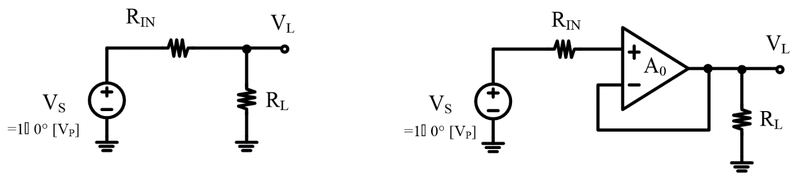 **Procedure:**

Voltage dividers: (a) passive alone, (b) with unity-gain buffer.

1. Implement the passive along circuit shown as above (a). (Rin = 2K, RL = 2K)
2. Using function generator to generate the AC voltage source, and set the amplitude to be 2, the frequency to be 1kHz, DC offset to be 0.
3. Using oscilloscope to output waveform VL(t) and Vs(t);
4. 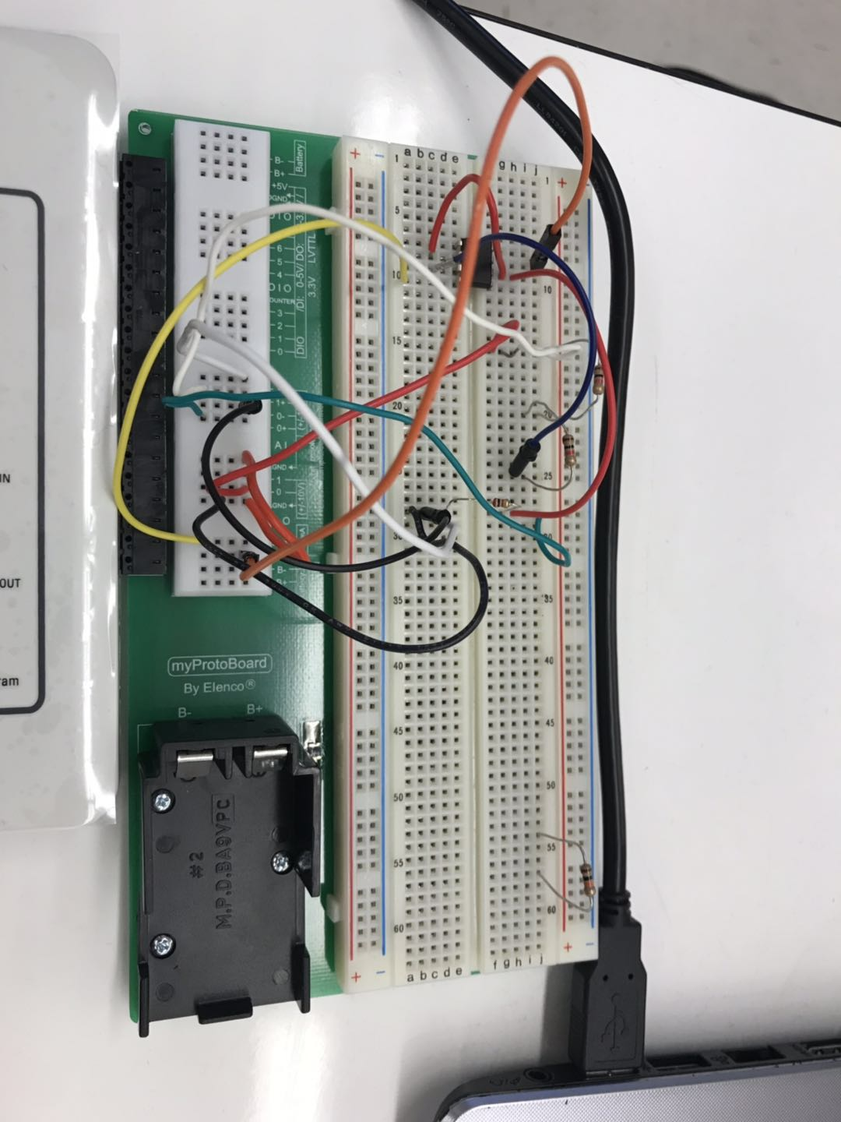Implement the unity-gain buffer circuit shown as above (b). (Rin = 2K, RL = 2K)
5. Repeat step 2 and step 3.

**Data:**

Part a:

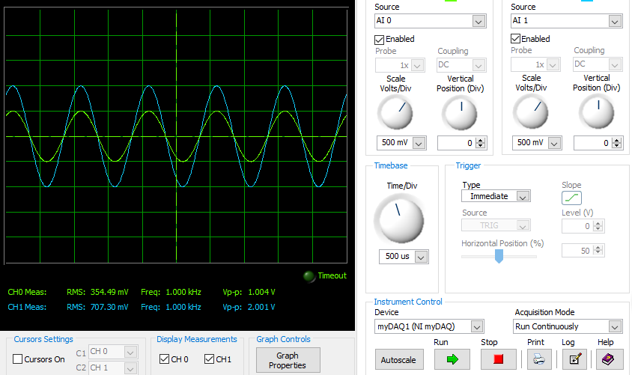

Part b:

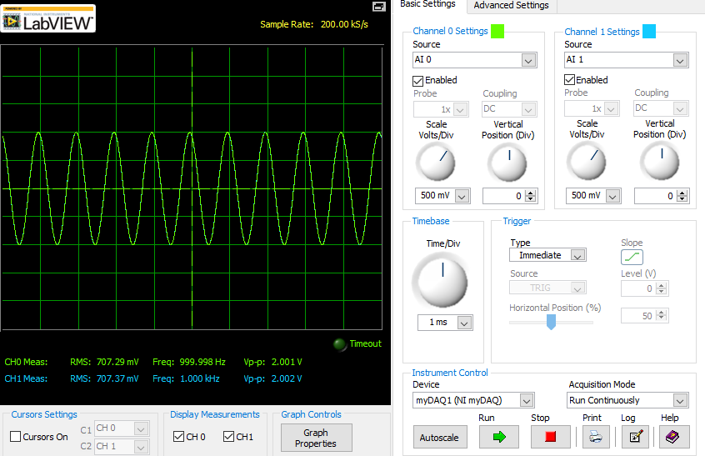

**Data Analysis:**

|  |  |  |
| --- | --- | --- |
|  | **VL** | **Vs** |
| **Part a** | 354.49mV | 707.30mV |
| **Part b** | 707.29mV | 707.37mV |

|  |  |  |  |
| --- | --- | --- | --- |
|  | **Theoretical VL/VS** | **Experimental VL/VS** | **Error %** |
| **Part a** | 0.499 | 0.50 | 0.20 |
| **Part b** | 1 | 0.9999 | 0.01 |

Part a calculation:

Theoretical:VL = Vs*(RL/(RL+RIN)), VL/Vs = 0.5, VL = 707.29mV * 0.5 = 353.645mV

VL/VS = 353.645mV/707.30mV = 0.499

Part b calculation:

Theoretical: VL = Vs = 707.37mV, VL/Vs = 1.

Error %:

Error % = 100*(0.50-0.499)/0.50 = 0.20%

**Discussion:**

From the data analysis, the percent error is very small, the experimental value for part a and part b verifies the theoretical value. In the part a, the voltage is divider into a half of the Voltage source by the two same resistors in series in circuit. The transfer function VL/Vs = 0.5. In the part b, the VL/VS is about equal to 1 due to the Op-Amp. The Op-Amp acts as a unity-gain buffer, and it prevents the current flows from the source to the load. Therefore, it prevents the voltage divider, the gain is 1.

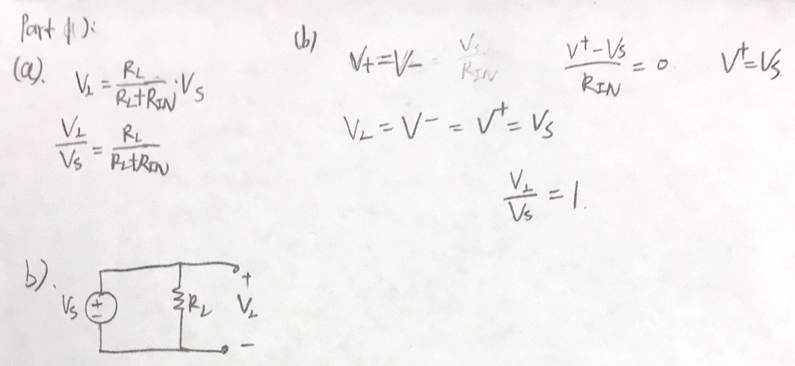 a), b):

**Part 2: Unity-Gain buffer design – II**

**Objectives:**

The purpose of part 2 is to design a circuit using an operational amplifier as a unity-gain buffer that matches the behavior of a RC series network which is a low pass filter.

**Theory:**

The transfer function for part a is:

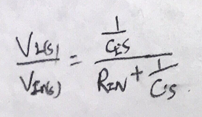

**Procedure:**

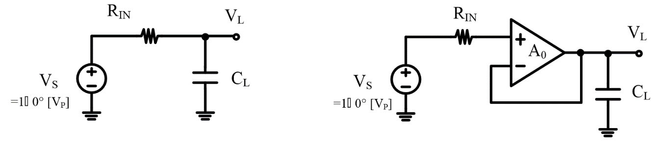

(a) passive alone, (b) with unity-gain buffer.

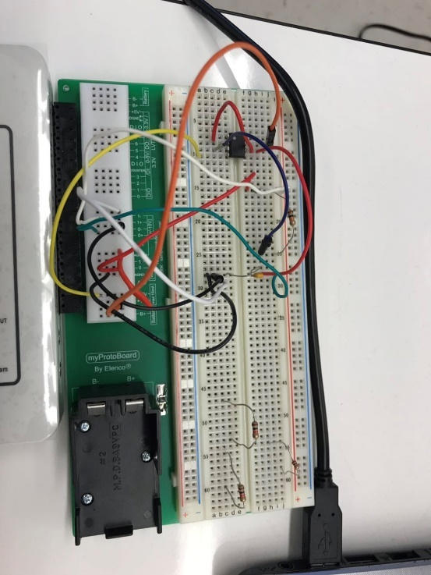

1. Implement the passive along circuit shown as above (a). (Rin = 10Kohm, CL = 100nF)
2. Using function generator to generate the AC voltage source, and set the amplitude to be 2, the frequency to be 100Hz, DC offset to be 0.
3. Using oscilloscope to output waveform VL(t) and Vs(t);
4. Implement the unity-gain buffer circuit shown as above (b). (Rin = 10Kohm, CL = 100nF)
5. Repeat step 2 and step 3
6. Draw the Bode plot for both cases part a and part b.

**Data:**

Case a: 100Hz: output waveform

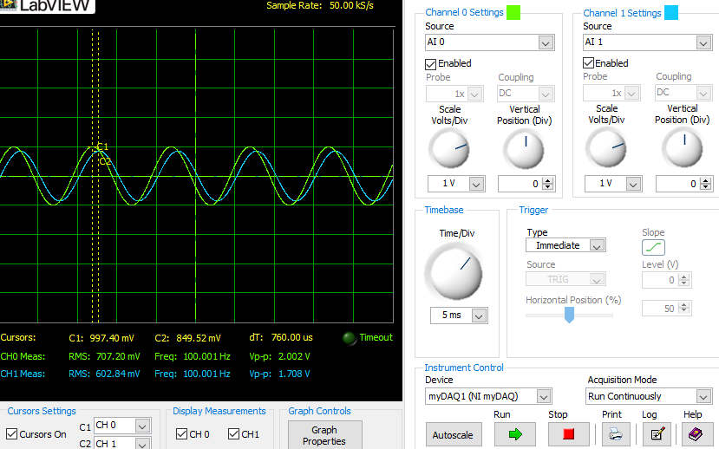

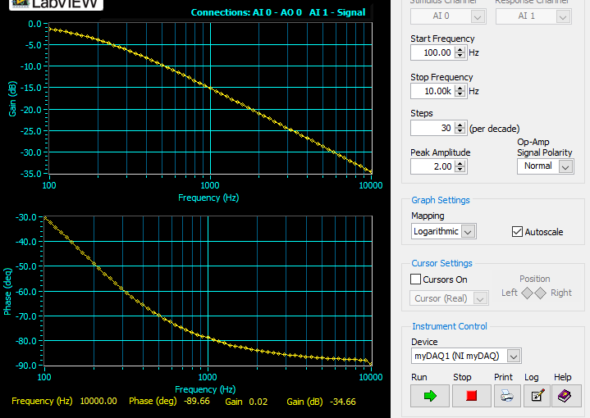Bode plot part a:

1000Hz: output waveform

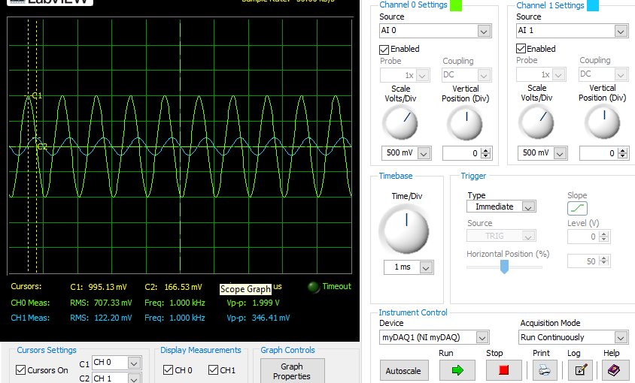

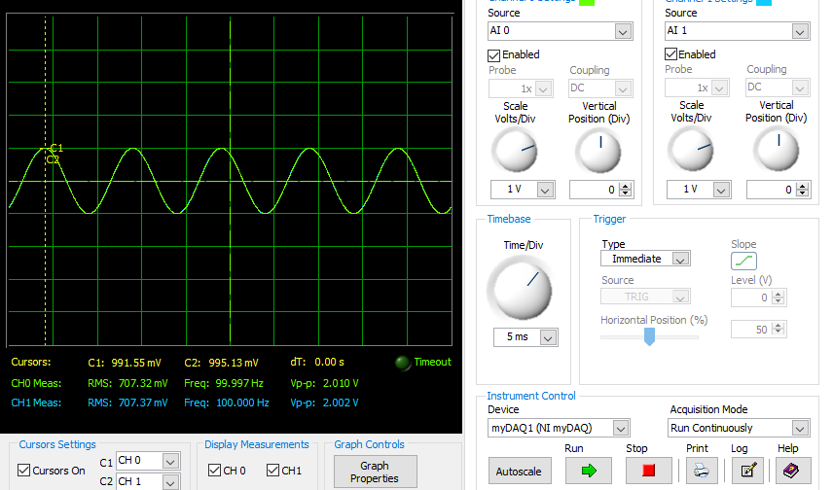Case b: 100Hz: output waveform

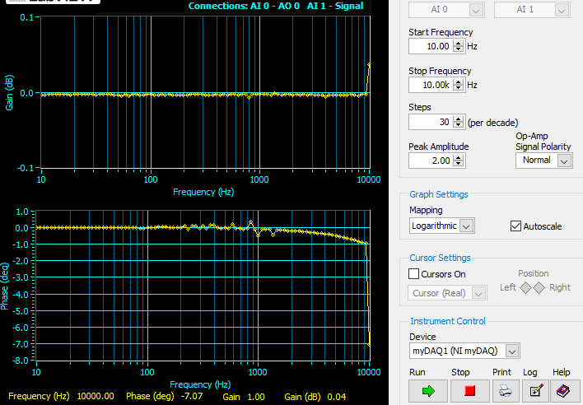Bode plot part b:

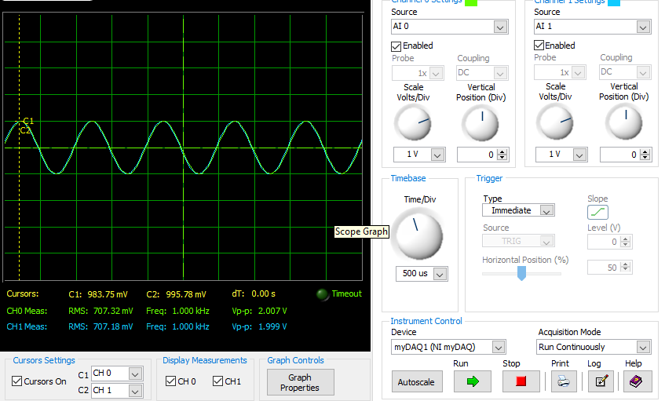1000Hz: output waveform

**Data Analysis:**

|  |  |  |
| --- | --- | --- |
|  | **VL** | **Vs** |
| **Part a (100Hz)** | 602.84mV | 707.20mV |
| **Part a (1k Hz)** | 122.20mV | 707.33mV |
| **Part b (100Hz)** | 707.37mV | 707.32mV |
| **Part b (1k Hz)** | 707.18mV | 707.32mV |

|  |  |  |  |
| --- | --- | --- | --- |
|  | **Theoretical VL/VS** | **Experimental VL/VS** | **Error %** |
| **Part a (100 Hz)** | 0.8467 | 0.8524 | 0.673% |
| **Part a (1k Hz)** | 0.157 | 0.1728 | 10.06% |
| **Part b (100 Hz)** | 1 | 0.9999 | 0.01% |
| **Part b (1 kHz)** | 1 | 0.9998 | 0.02% |

Calculation:

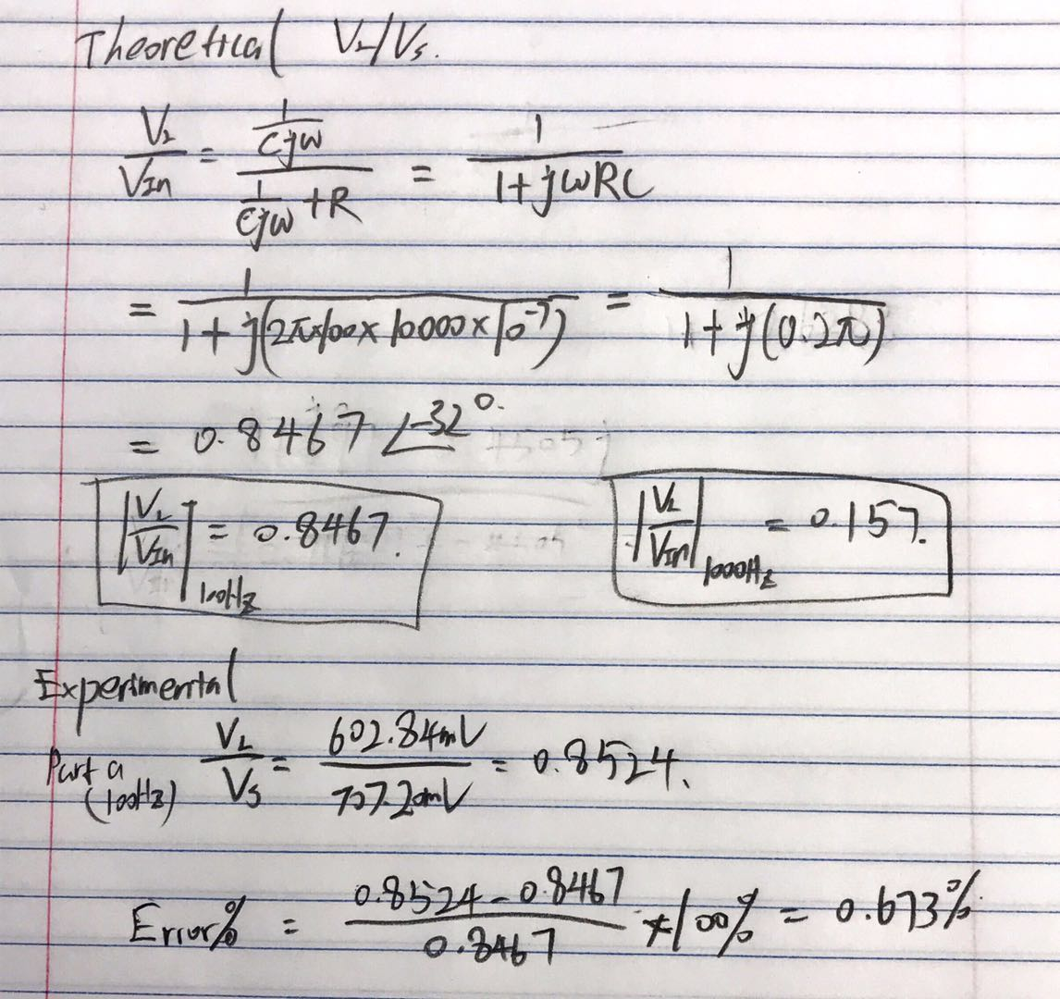

**Discussion:**

The percent error is very small except for part a) circuit at 1kHz frequency because the value of this transfer function (VL/Vs) is very small which is about 0.157. The Experimental value is 0.1728 which is also very close to the theoretical value. Also, the myDAQ has limitations to measure the small-scale value. Therefore, it makes this percent error bigger. The low pass filter circuit network would filter out the high frequency voltage. We can see that the VL for part a) at 1kHz is much smaller than part a) 100Hz. After adding the unity-gain buffer, the behavior of low pass filter is broken. The VL is the same as Vs. Therefore, adding the unity-gain buffer would not have the same behavior of low pass filter. The transfer functions VL/VIN are different.

a), They are not the same.

b),

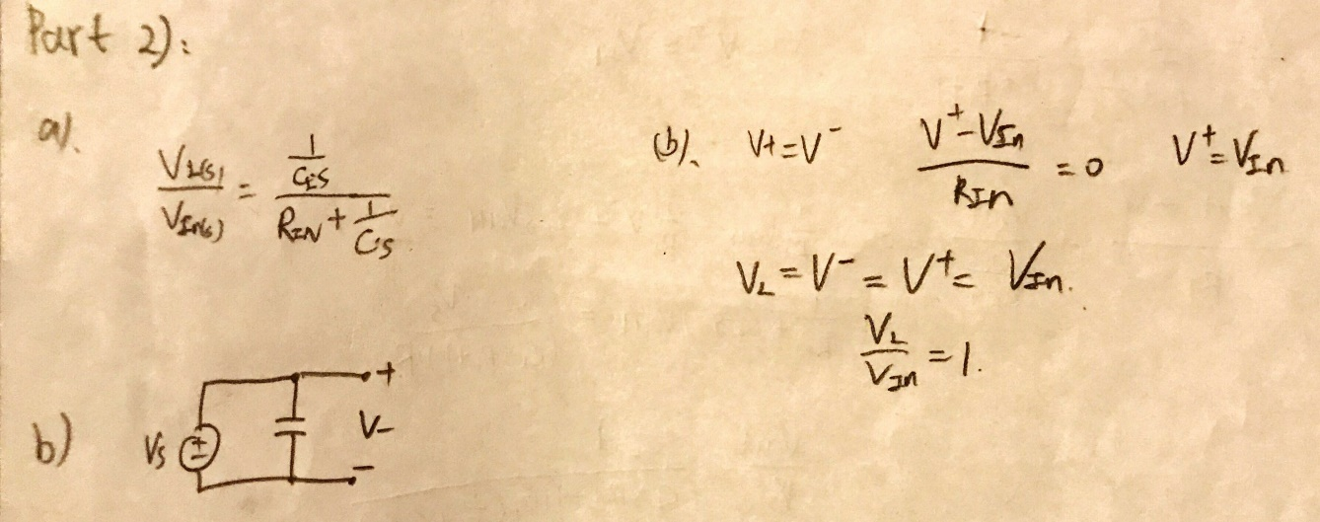

**Part 3: 2nd-Order LPF design**

**Objectives:**

The purpose of part 3 is to design a second order low-pass filter using two cascaded first order passive filter (resistors and capacitors)

**Theory:**

The transfer function for two cascaded 1st-order passive filter is:



**Procedure:**

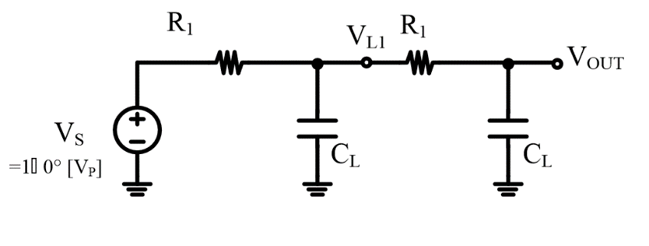

Passive 2nd-Order filter

1. Implement 2nd -order RC LPF (R1 = 10K, CL = 100n)
2. 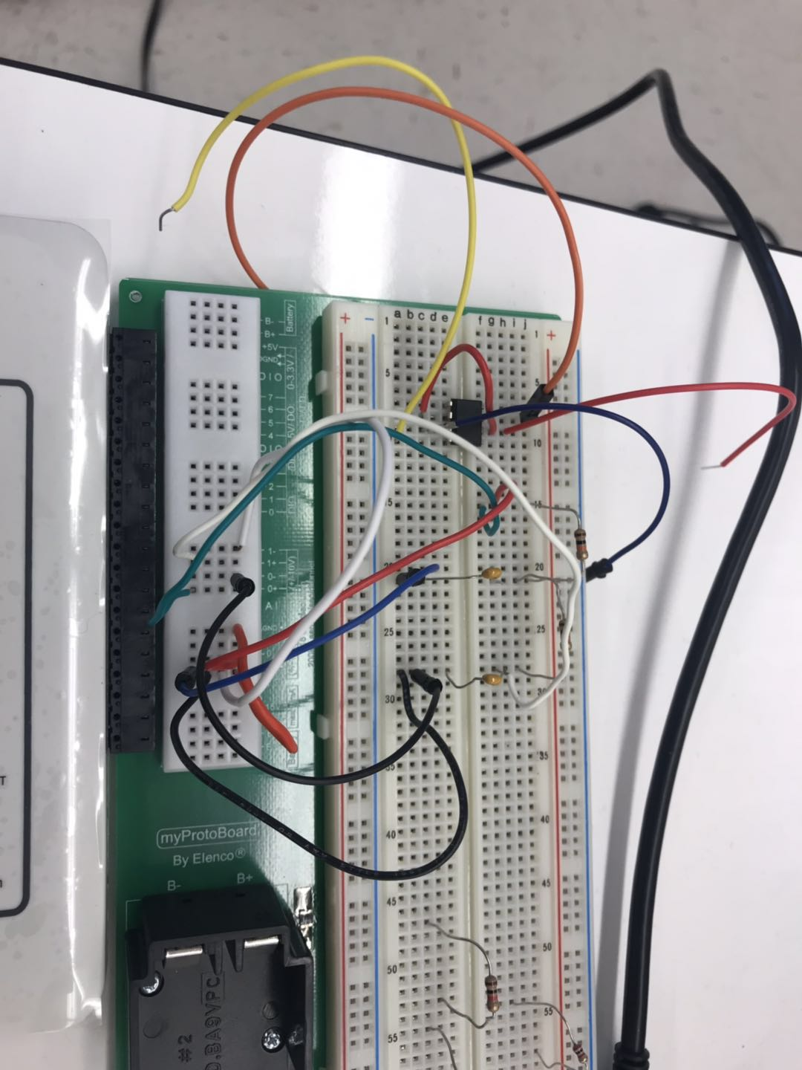 Using function generator to generate the AC voltage source, and set the amplitude to be 2, the frequency to be 100Hz and 1kHz, DC offset to be 0.
3. Using oscilloscope to output waveform VL1(t), Vout(t) and Vs(t);
4. Draw Bode plot for VL1 and VOUT using ‘Bode’ in myDAQ.

**Data:**

**100Hz: VL1 vs Vs**

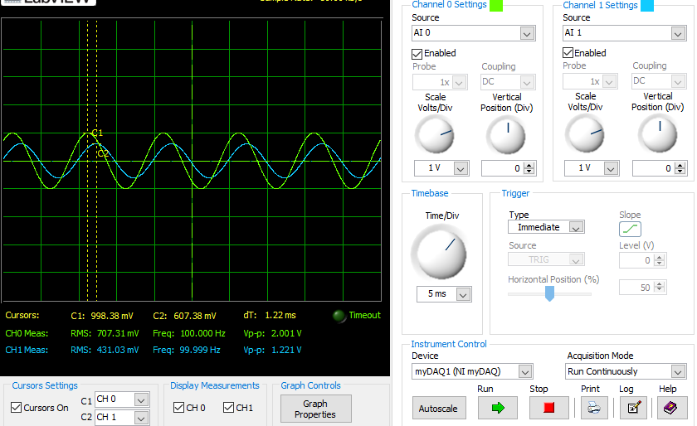

Bode plot 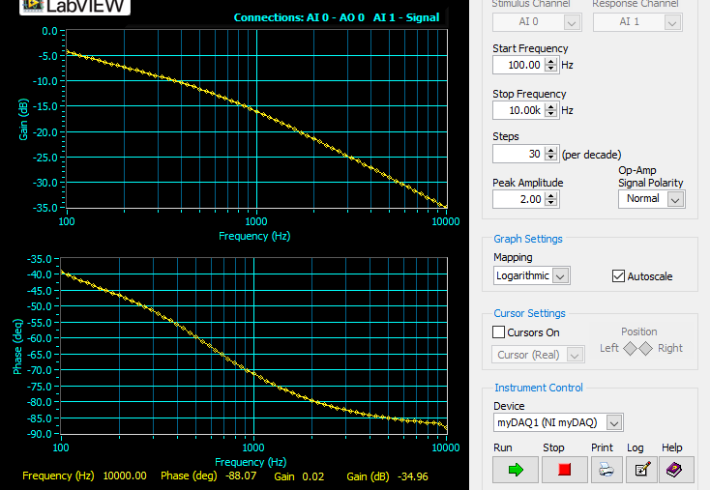for VL1

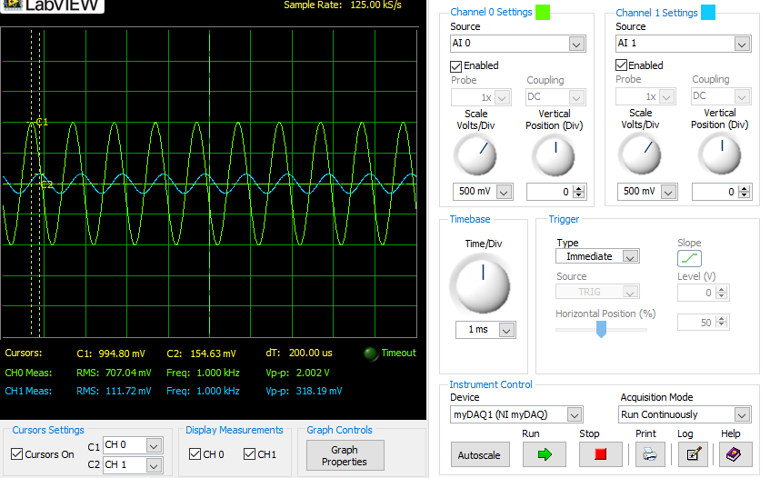**1000Hz: VL1 vs Vs**

**100Hz: Vout vs Vs**

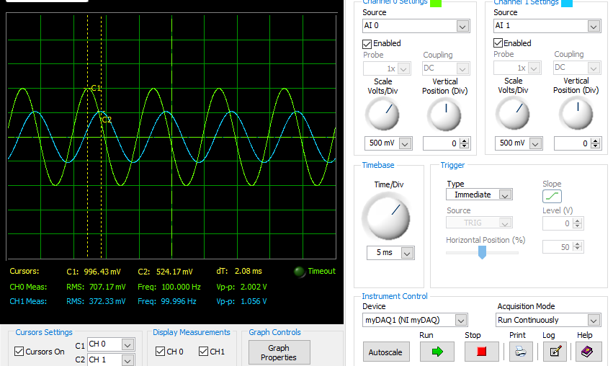

Bode plot 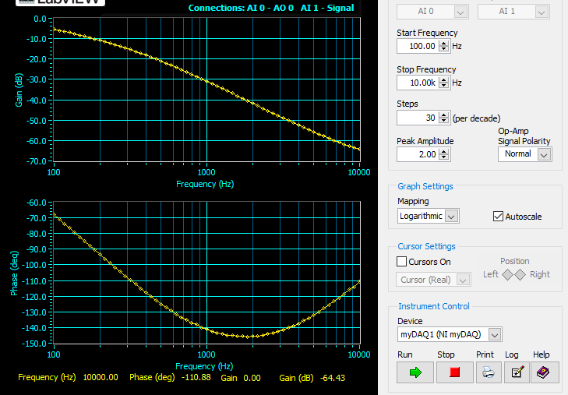Vout

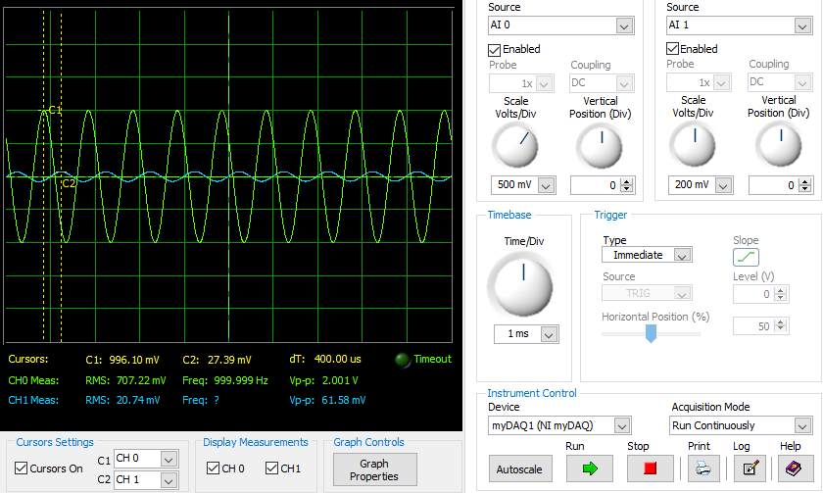**1000Hz: Vout vs Vs**

**Data Analysis:**

|  |  |  |
| --- | --- | --- |
|  | **Vout** | **Vs** |
| **100Hz** | 372.33mV | 707.17mV |
| **1k Hz** | 20.74mV | 707.22mV |

|  |  |  |
| --- | --- | --- |
|  | **VL** | **Vs** |
| **100Hz** | 431.03mV | 707.31mV |
| **1k Hz** | 111.72mV | 707.04mV |

|  |  |  |  |
| --- | --- | --- | --- |
|  | **Theoretical** | **Experimental** | **Error %** |
| **Vout/VS, 100 Hz** | 0.505 | 0.5265 | 4.25% |
| **Vout/VS, 1 kHz** | 0.023 | 0.0293 | 27.39% |

**Calculation:**

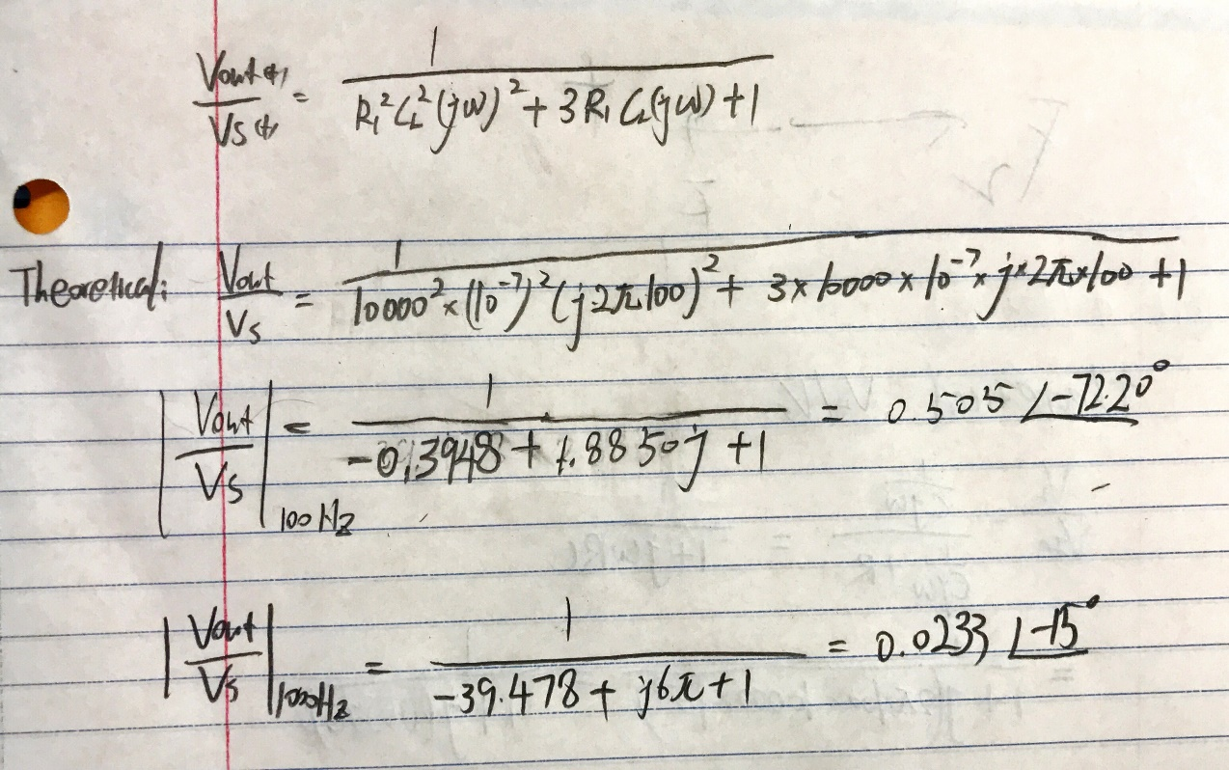

Experimental: **Vout/VS =** 372.33mV/707.17mV = 0.5265

**Discussion:**

The percent error of transfer function at frequency 1kHz for Vout is 27.39%. It might be caused through the myDAQ limitations and a non-ideal capacitor. The measurement for a higher frequency also reduces the accuracy of myDAQ.

 Due to this transfer function, we know that the gain (dB) and phasor of Vout is two times of VL1’s gain (dB) and phasor. However, from the Bode plot of Vout and VL1, we can find out that the output voltage transfer function does not match this requirement. In other words, it doesn’t match the square of the first-order transfer function. In addition, the higher frequency of the phasor of the output voltage transfer function goes up, which doesn’t match this requirement again. The first-order transfer function of phasor should keep going down (Bode plot VL1).

a),

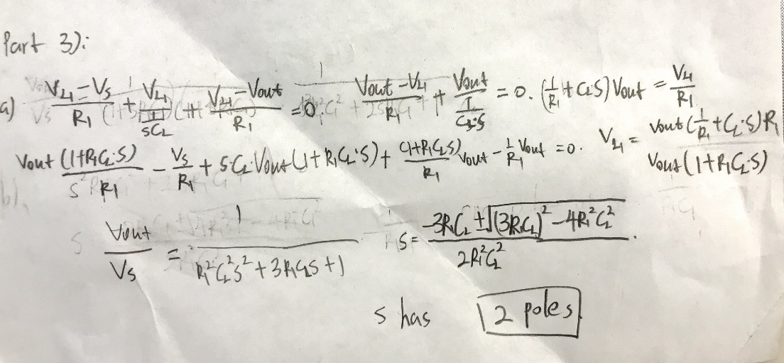

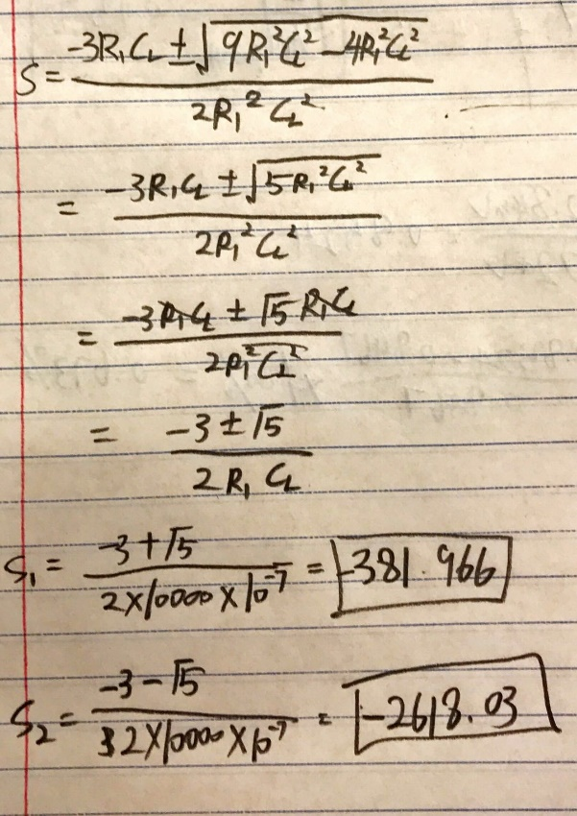 b),

**Part 4: 2nd-Order LPF design with a unity-gain buffer**

**Objectives:**

The purpose of part 3 is to design a second order low-pass filter by using a unity-gain buffer (Op-Amp) in between the two first order passive filter (resistors and capacitors)

**Theory:**

The transfer function for this part is:

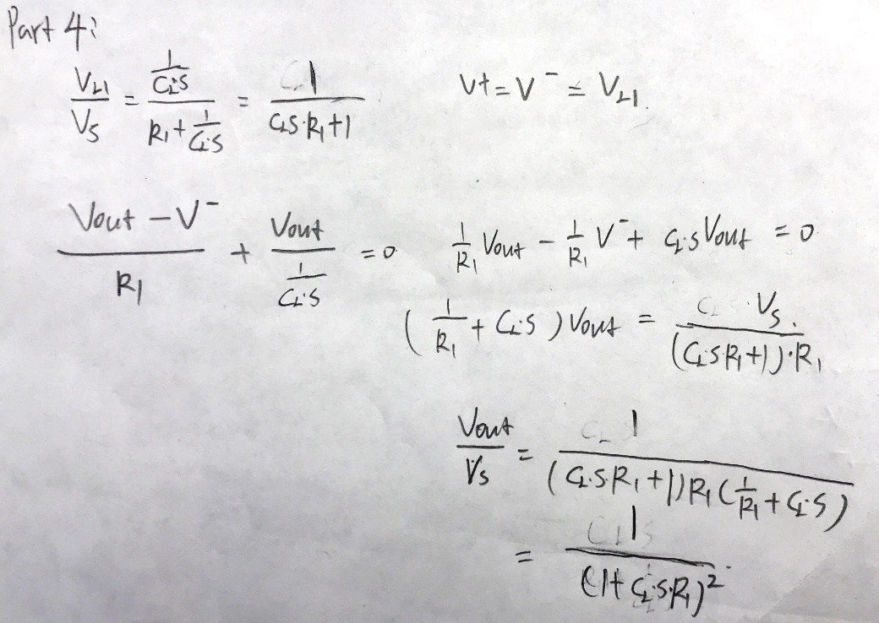

**Procedure:**

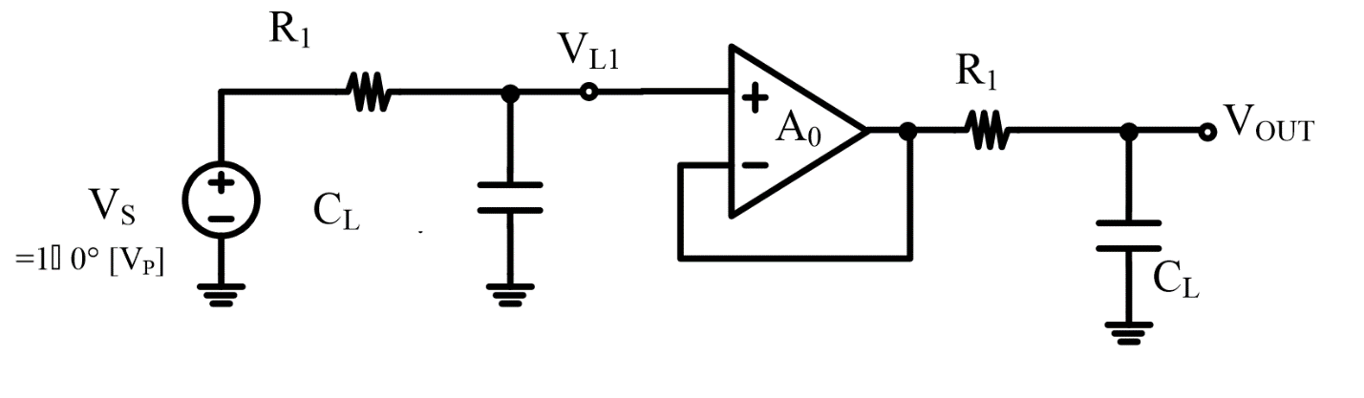

1. Implement 2nd -order RC LPF with a unit-gain buffer circuit as above (R1 = 10K, CL = 100n)
2. Using function generator to generate the AC voltage source, and set the amplitude to be 2, the frequency to be 100Hz and 1kHz, DC offset to be 0.
3. 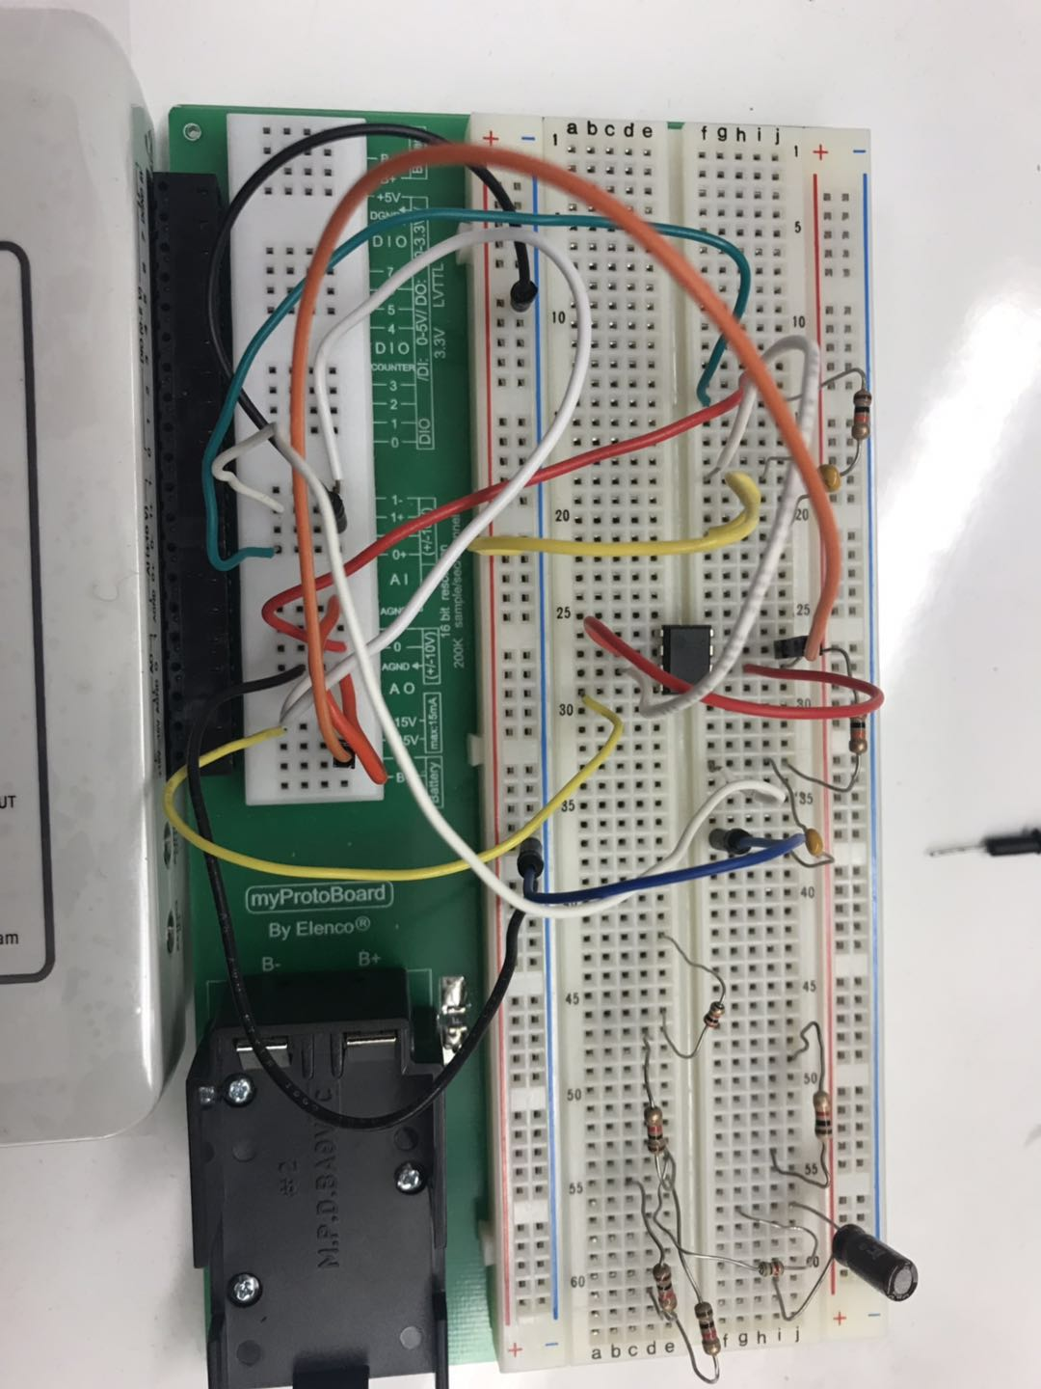Using oscilloscope to output waveform VL1(t), Vout(t) and Vs(t);
4. Draw Bode plot for VL1 and VOUT using ‘Bode’ in myDAQ.

**Data:**

**Bode plot at VL1**

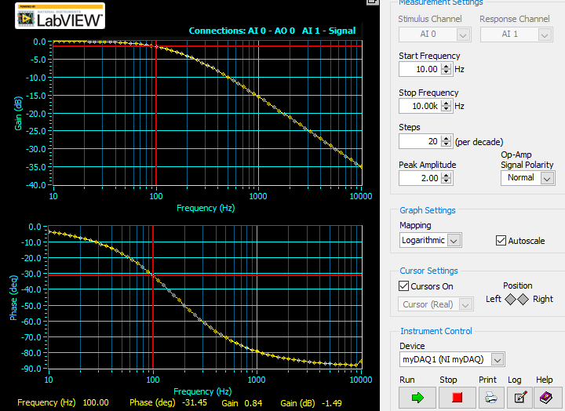

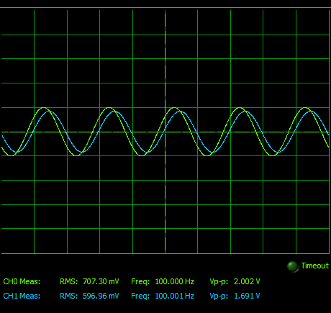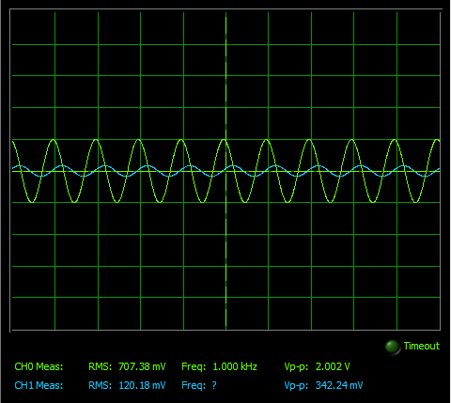**waveforms of VL1 and Vs at 100Hz at 1kHz**

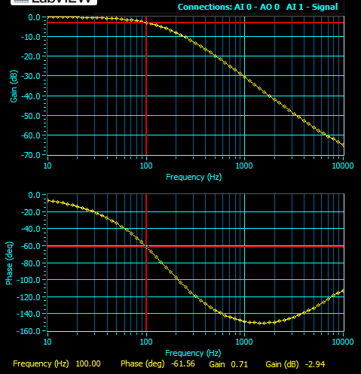 **Bode plot at Vout**

**waveforms of Vout and Vs at 100Hz at 1kHz**

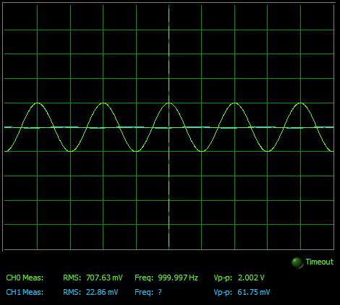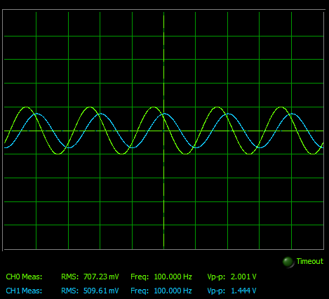

**Data Analysis:**

|  |  |  |
| --- | --- | --- |
|  | **VL1** | **Vs** |
| **100Hz** | 596.96mV | 707.30mV |
| **1k Hz** | 121.18mV | 707.38mV |

|  |  |  |
| --- | --- | --- |
|  | **Vout** | **Vs** |
| **100Hz** | 509.61mV | 707.23mV |
| **1k Hz** | 22.86mV | 707.63mV |

|  |  |  |  |
| --- | --- | --- | --- |
|  | **Theoretical** | **Experimental** | **Error %** |
| **Vout/VS, 100 Hz** | 0.717 | 0.721 | 0.558% |
| **Vout/VS, 1 kHz** | 0.0247 | 0.0323 | 30.77% |

Calculations:

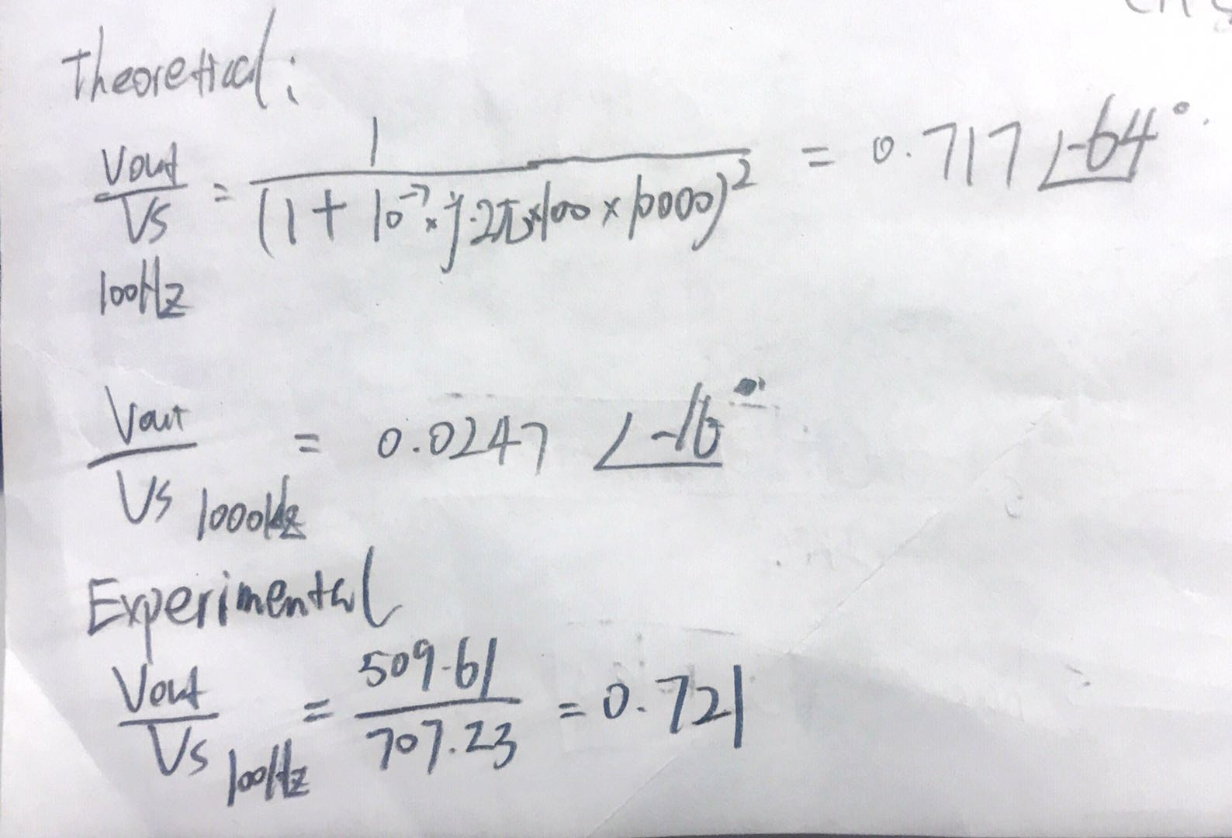

**Discussion:**

Due to the myDAQ limitation and the non-ideal capacitors, the experimental value of transfer function has higher error compared to the theoretical value for the high frequency measurement. In this part, with the unity-gain buffer (Op-Amp) which is implemented in between two first order passive filter, we successfully design a second order low-pass filter by using two cascaded first order passive filter. From the VL’sBode plot, the gain value is 0.84 at 100Hz. From the Vout’s Bode plot, the gain value is 0.71 at 100Hz. The square of 0.84 is equal to about 0.71 which is the same as Vout’s gain. Therefore, the transfer function of this second order filter is square of the transfer function of the first order filter.

a). In theory section.

b). From the bode plot, we can see that the Gain(dB) of the 2nd-order LPF response at VOUT is two times of the Gain(dB) of the 1st-order LPF response at VL1 the first order. The phase of Vout is also two times of the phase of VL1

c). The 3dB bandwidth of the filter is 2*pi*100 = 628.32rad/s

d). There are two poles, and they are equal to -10^3

e). The LPF response in part 3 has two different poles, while the LPF in this part has two same poles. The unity-gain buffer in between two first order filter makes the transfer function of network become the square of the transfer function of a first order filter.

**Part5: Inverting / Non-Inverting gain amplifiers.**

**Objectives:**

The purpose of this part is to build an Inverting / Non-inverting gain amplifier to verify the superposition theorem.

**Theory:**

The superposition theory shows that the response in any element of LTI linear circuit network which has more than one sources is the sum of the responses produced by the sources each acting independently.

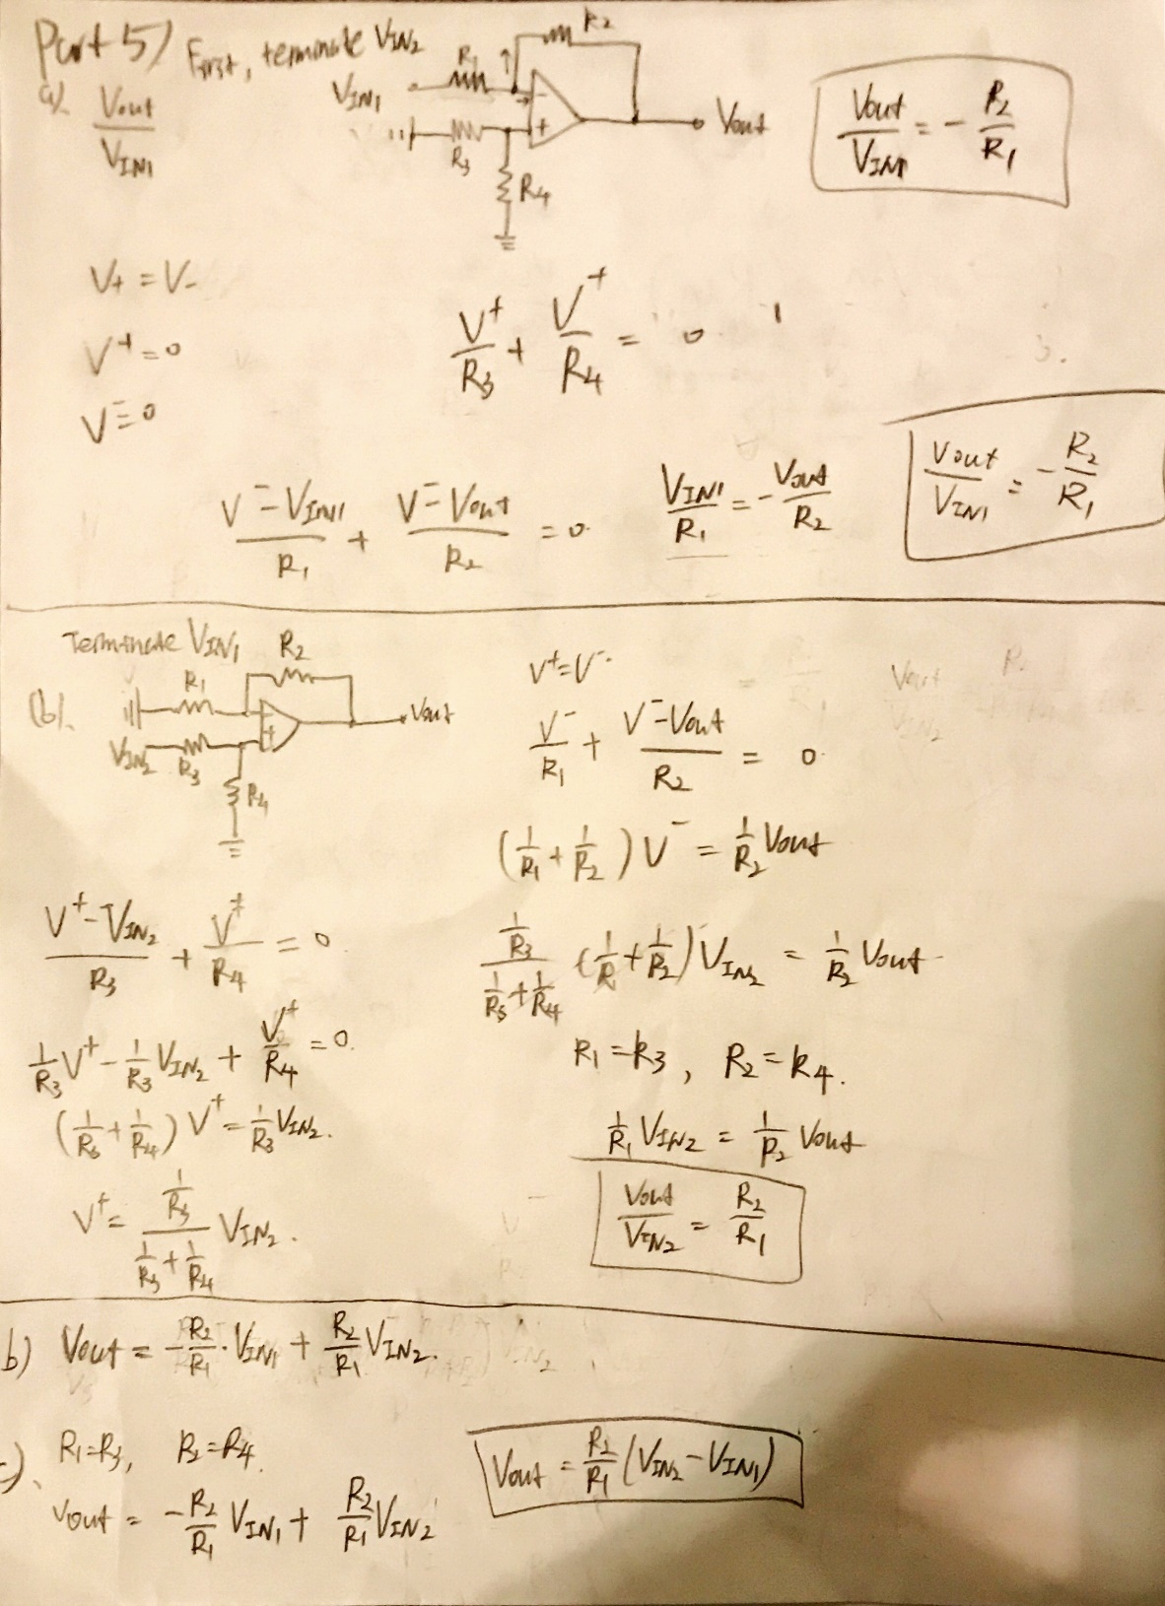The functions used to verify superposition theory in this part are:

**Procedure:**



1. Implement the circuit as above. Set up the R1~R4 as 1kOhm, fIN = 100 Hz in this test.
2. Terminating VIN2, Draw VIN1(t), and VOUT(t)
3. Terminating VIN1, Draw VIN2(t), and VOUT(t)
4. Set VIN1(t) = sin(2π×100Hz×t), VIN2(t) = sin(2π×100Hz×t) with ARB, and draw the output.
5. Set VIN1(t) = sin(2π×100Hz×t), VIN2(t) = -sin(2π×100Hz×t), and draw the output.
6. Set VIN1(t) = sin(2π×100Hz×t), VIN2(t) = -sin(2π×100Hz×t). Draw the output.
7. 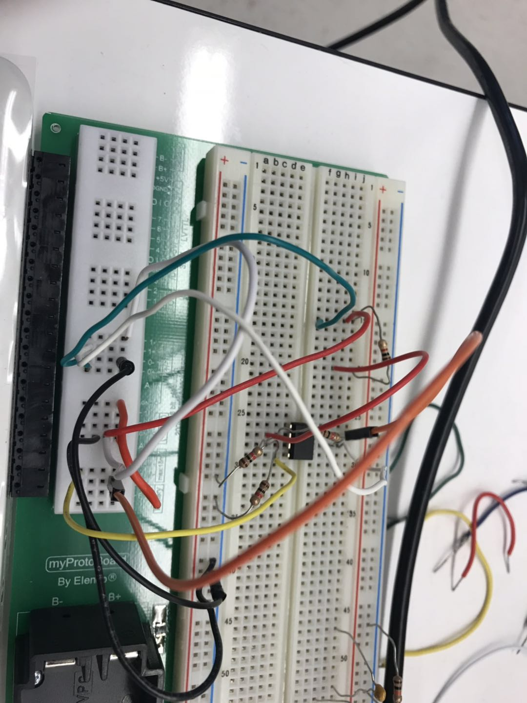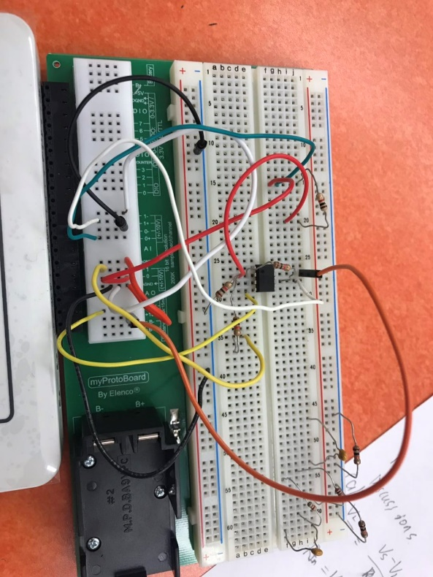Set VIN1(t) = sin(2π×100Hz×t), VIN2(t) = -sin(2π×1000Hz×t). Draw the output and its spectrum.

**Data:**

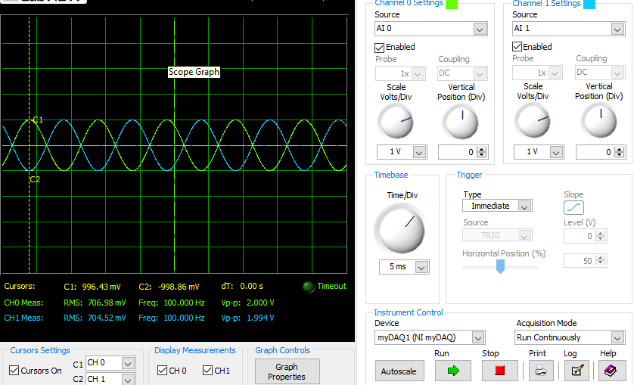**Terminating VIN2: Vout and VIN1 fin = 100Hz (inverting Amp)**

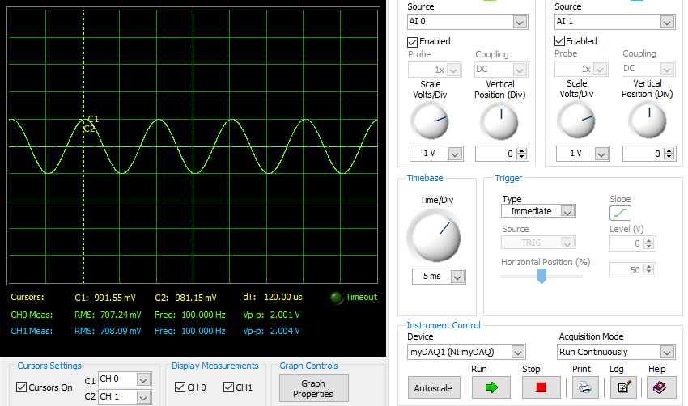**Terminating VIN1: Vout and VIN2 fin = 100H (non-inverting Amp)**

**Step 4: VIN1(t) = sin(2π×100Hz×t), VIN2(t) = sin(2π×100Hz×t)**

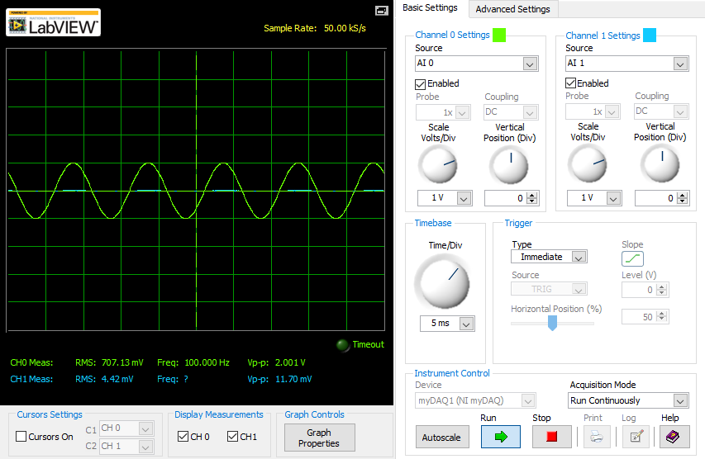

**Step 5: VIN1(t) = sin(2π×100Hz×t), VIN2(t) = -sin(2π×100Hz×t)**

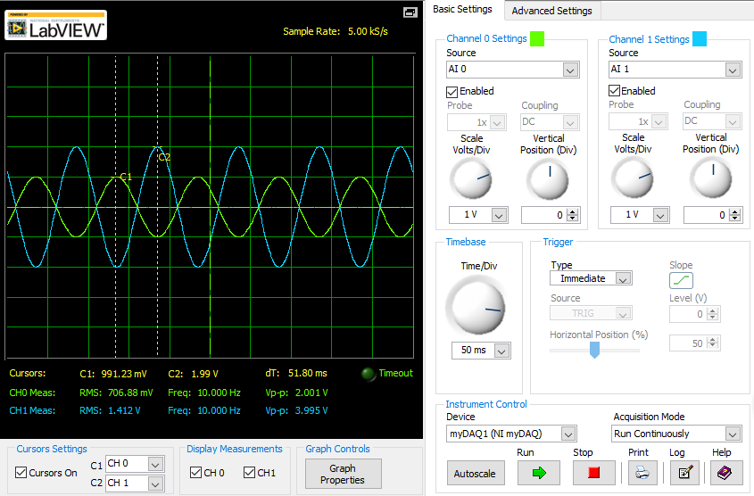

**Step 6: VIN1(t) = sin(2π×100Hz×t), VIN2(t) = -sin(2π×1000Hz×t)**

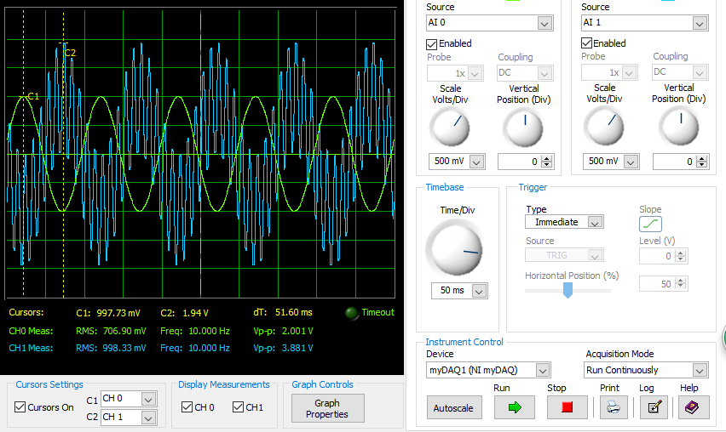

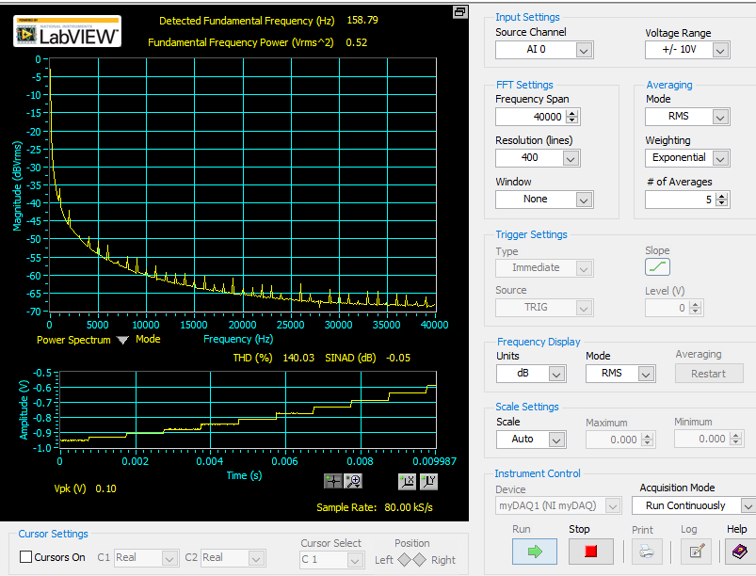**The** **spectrum:**

**Data Analysis:**

|  |  |  |
| --- | --- | --- |
|  | **Vout** | **Vs** |
| **Inverting (**Vout/Vin1**)** | -704.52mV | 706.98mV |
| **non-Inverting (**Vout/Vin2**)** | 708.09mV | 707.24mV |

|  |  |  |  |
| --- | --- | --- | --- |
|  | **Theoretical** | **Experimental** | **Error %** |
| **Step 4 Vout (Vp)** | 0.0V | 4.42mV | None |
| **Step 5 Vout (Vp)** | -2V | -1.99V | 0.5% |
| **Step 6 Vout (Vp)** | -2V | -1.94V | 3.0% |

|  |  |  |  |
| --- | --- | --- | --- |
|  | **Theoretical** | **Experimental** | **Error %** |
| **Inverting (**Vout/Vin1**)** | -1.0 | -0.9965 | 0.35% |
| **non-Inverting(**Vout/Vin2**)** | 1.0 | 1.001 | 0.1% |

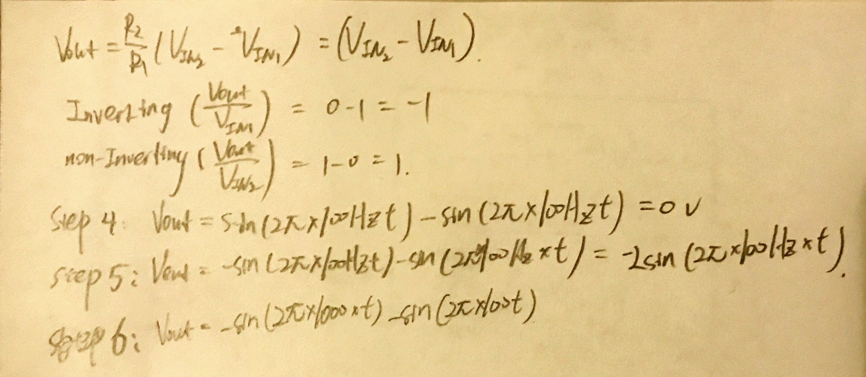Calculation:

**Discussion:**

In this part, the experimental values match the theoretical values, and the percent error is very small. Therefore, the implement of Op-Amp in this circuit accurately works the inverting and non-inverting amplifier. To verify the superposition theorem, we terminate VIN2 and measure the output voltage. Then, we terminate VIN1 and measure the output voltage. The sum of these two output voltages is about equal to 0. The superposition theorem is verified. Throughout the step 4 to step 6, we verify the transfer function . Step 6 is the subtraction of two different frequency sinusoid inputs.

a), b), c) answers are in theory section.

**Part 6: Active filter design**

**Objectives:**

The purpose of part 6 is to design an active LPF that meets the required specifications.

**Theory:**

The transfer function for this part is below:

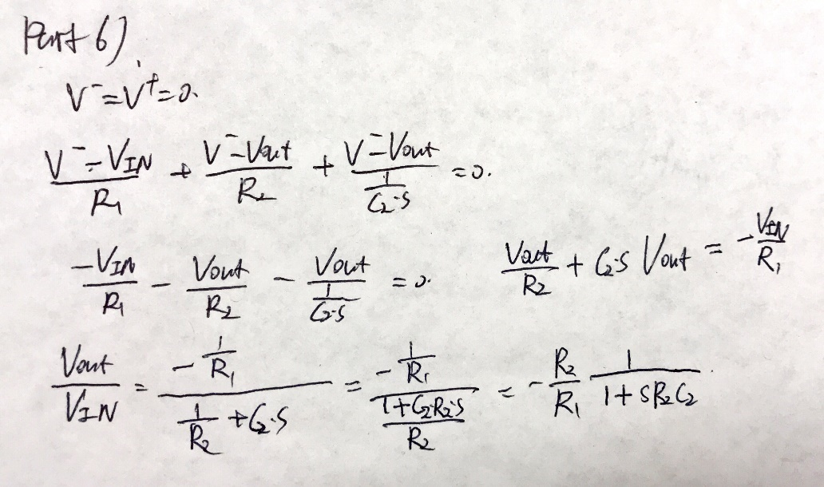

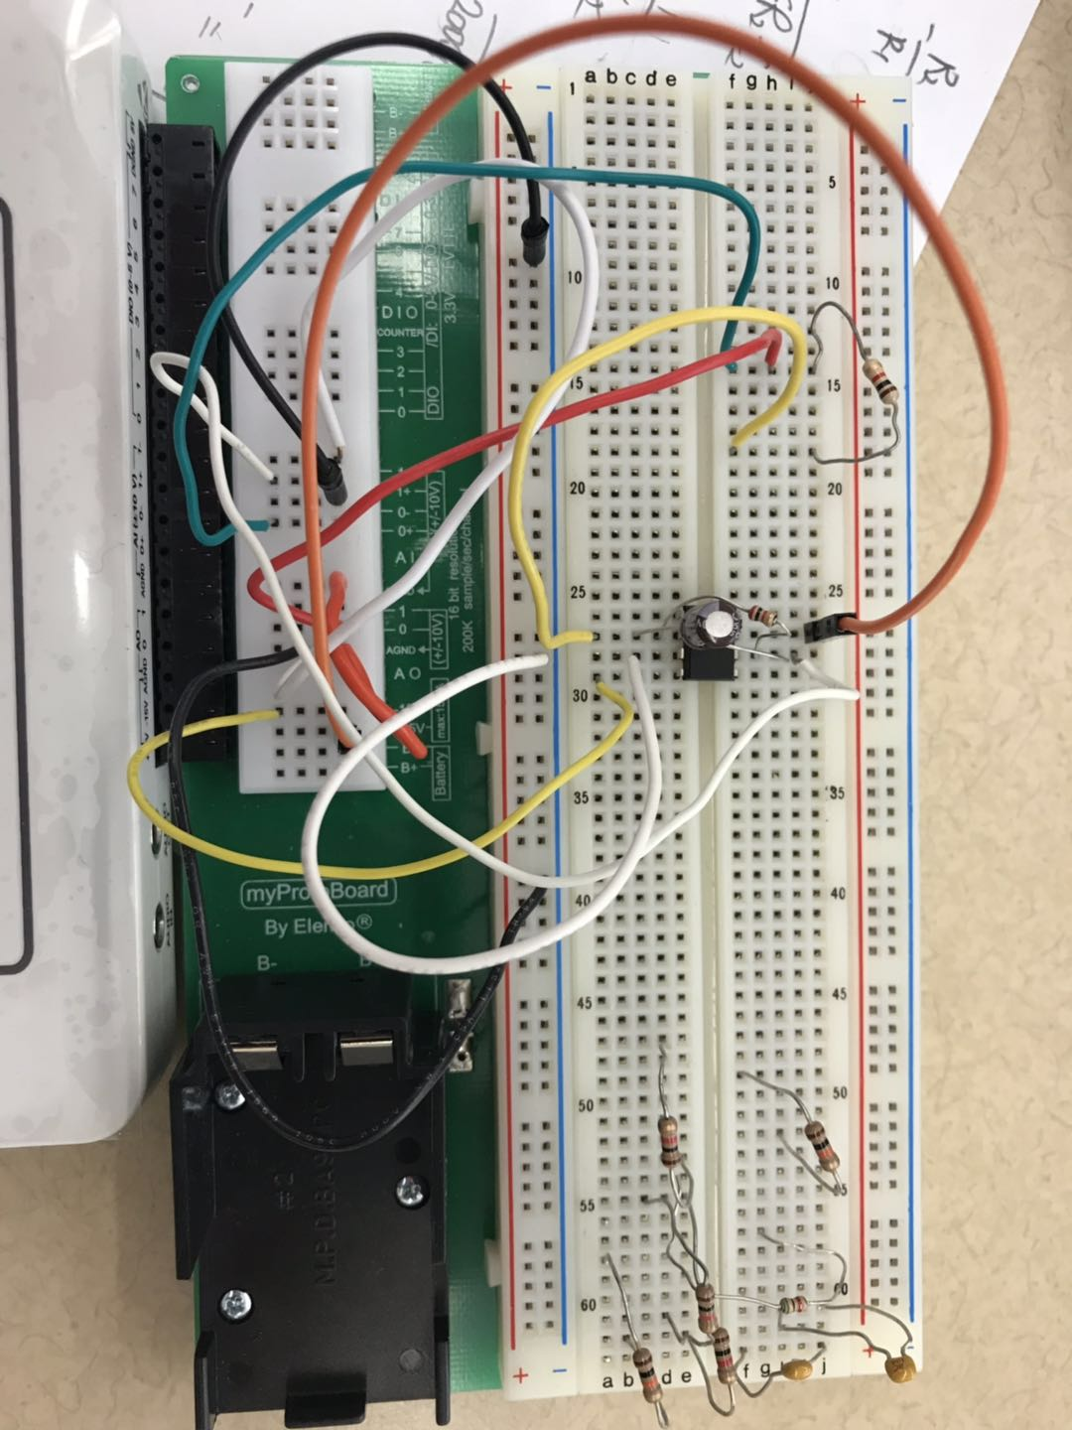**Procedure:**



Active LPF (R1 = 1kohm)

1. Implement the active LPF circuit as above.
2. Draw the Bode plot using the transfer function by MATLAB and compared to the BODE function module result.

**Data**:

**Bode plot at frequency 10Hz Bode plot at Gain(dB) 3.01**

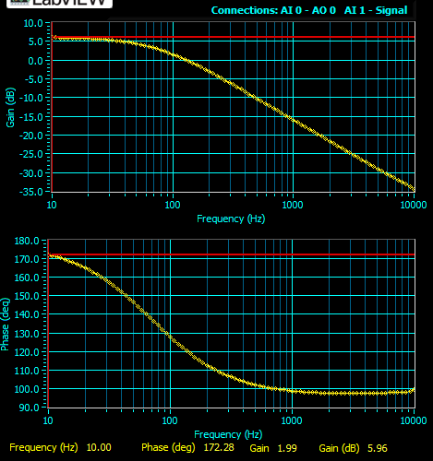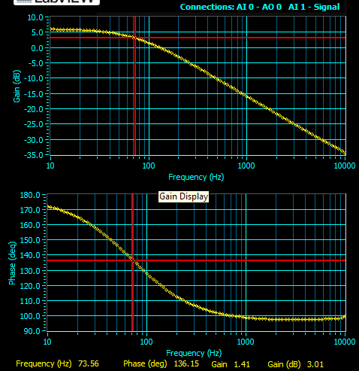

**Bode plot at frequency 100Hz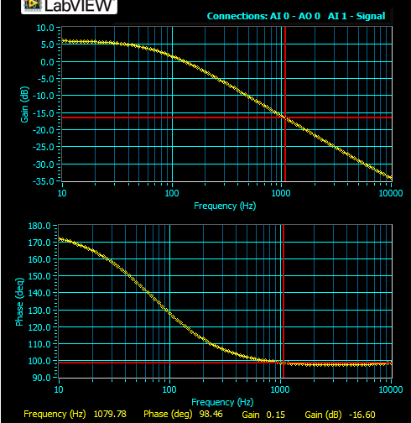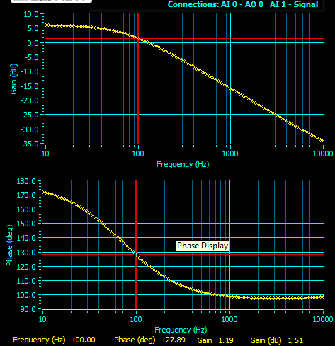 Bode plot at frequency 1000Hz**

**Data Analysis:**

From the Bode plot at Gain(dB) 3.01, the frequency is 73.56Hz. The theoretical frequency for 3-dB bandwidth is 80Hz. The percent error is (80-73.56)/80*100 = 8.05%.

|  |  |  |
| --- | --- | --- |
|  | **Gain** | **Gain(dB)** |
| **10Hz** | 1.99 | 5.96 |
| **100Hz** | 1.19 | 1.51 |
| **1000Hz** | 0.15 | -16.60 |

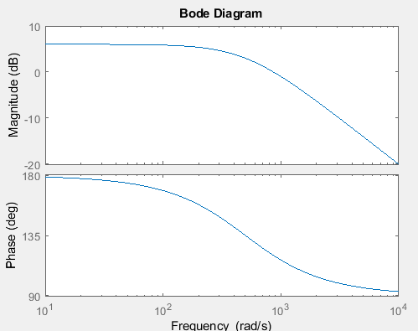

**Bode plot by MATLAB:**

**Discussion:**

The myDAQ measurement limitations and non-ideal capacitor would produce the percent error. The bode plot generated by myDAQ approximately matches the bode plot by using MATLAB. We can see that as the frequency increases, the gain of this circuit is decreases. Also, when the frequency is close to 0, the gain is equal to 2. The low pass filter is designed successfully with the gain of 2 at lowest frequency.

a), In the theory section.

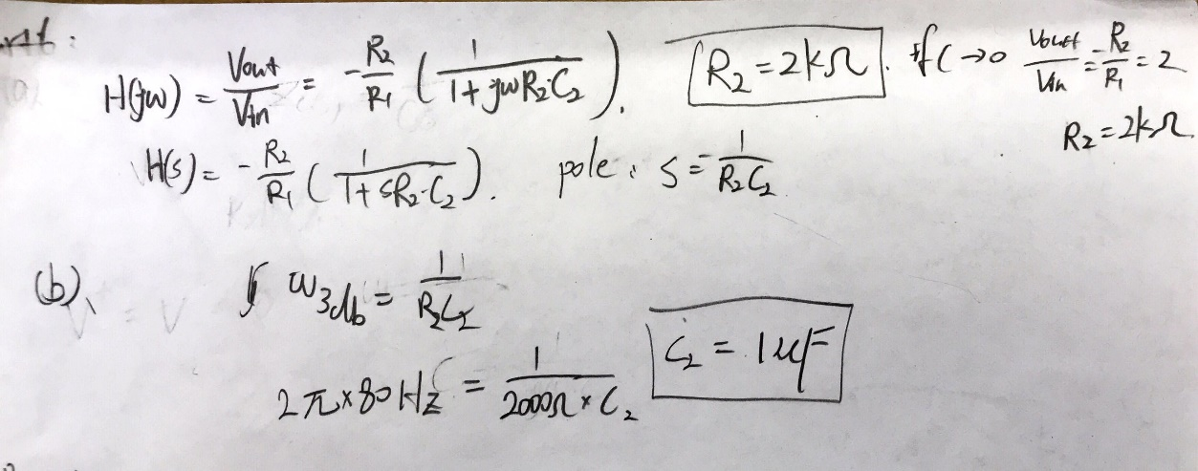b).

**Part 7: Integrator design**

**Objectives:**

The purpose of this part is to design and analyze an integrator.

**Theory:**

The transfer function for this part is below:

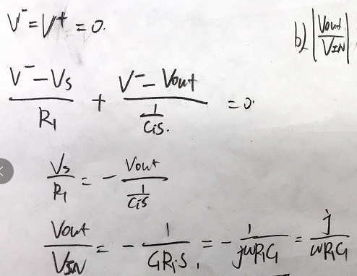

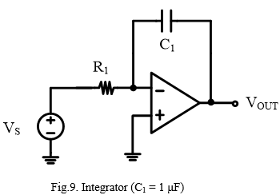**Procedure:**

1. Implement the integrator circuit as above (R1 = 1000Ohm)
2. Using Arbitrary waveform generator to generate VIN(t) = cos(2π×1kHz×t) [VP] and measure the Vout.
3. Using function generator to generate rectangular signal with an amplitude of 1 VP and 1 kHz input frequency and measure the Vout.

**Data:**

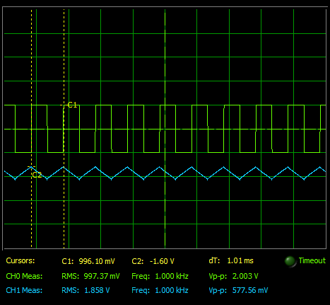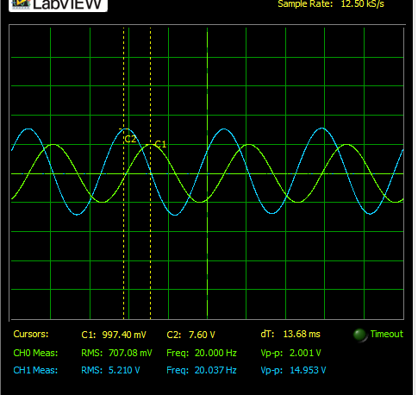 **Vout(t) when VIN(t) = cos(2π×1kHz×t) Vout(t) when rectangular signal**

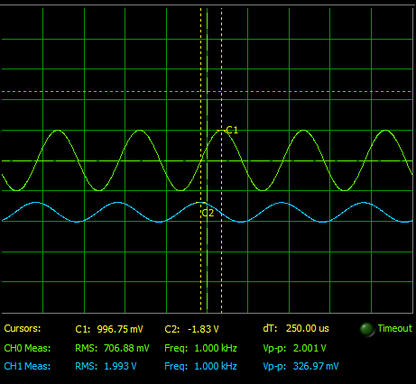 **Vout for function generator (1kHz)** **Bode plot:**

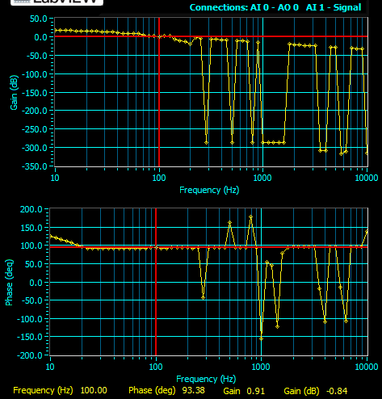

**Data analysis:**

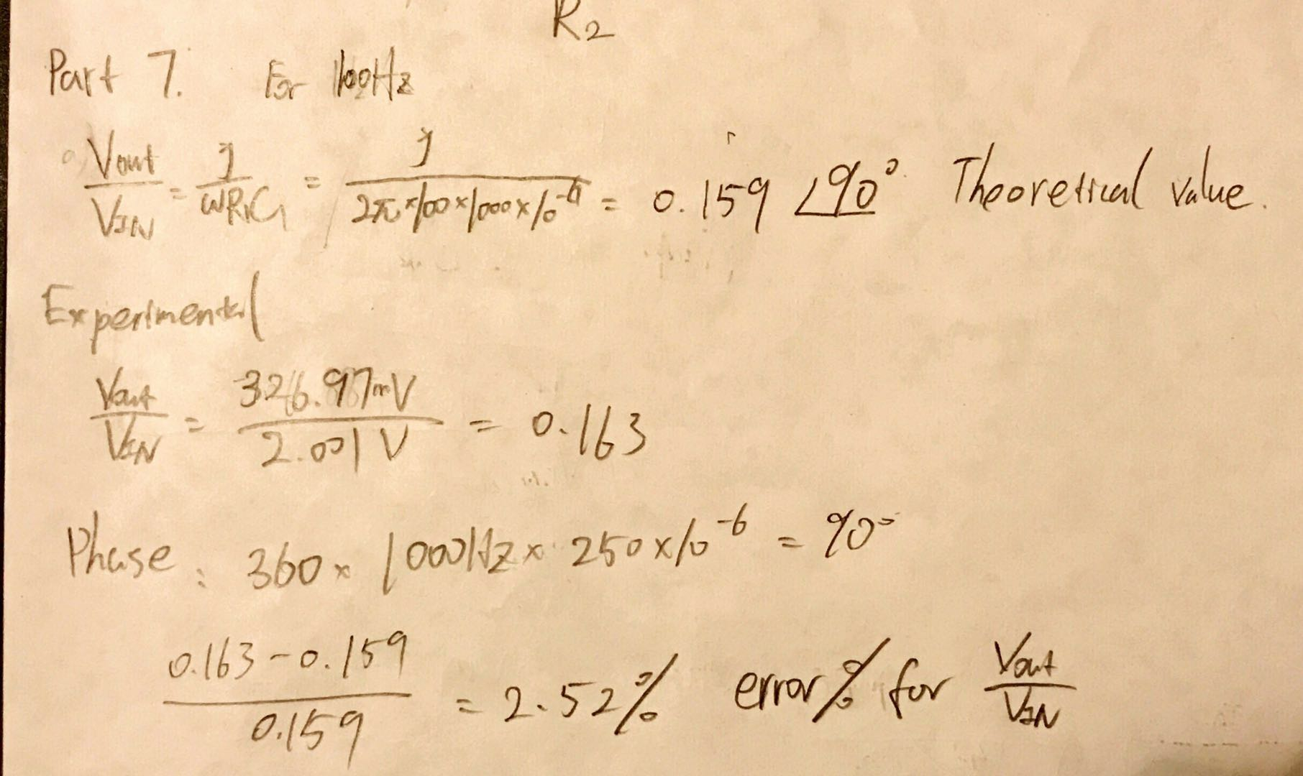 Due to the Arbitrary waveform generator which cannot accurately generate cos(2π×1kHz×t) stable voltage, I use function generator to generate a sin(2π×1kHz×t) voltage to measure the data.

**Discussion:**

From the data analysis, we can see that the experimental phase is 90 degree, and the gain is 0.163 at 1kHz. They are theoretically predicted. From the Bode plot, before the graph messes up, we can see that the gain(dB) is a horizontal line. It means that the slope of gain is a constant. The phase is also equal to 90 degree. From the rectangular signal, we can see that the output voltage is triangle signal. The Integrator is designed successfully. In addition, the reason for the bode plot messes up at higher frequency is that the gain is almost equal to zero after 100Hz. Therefore, the myDAQ cannot accurately measure the rest of gain(dB) and phase.

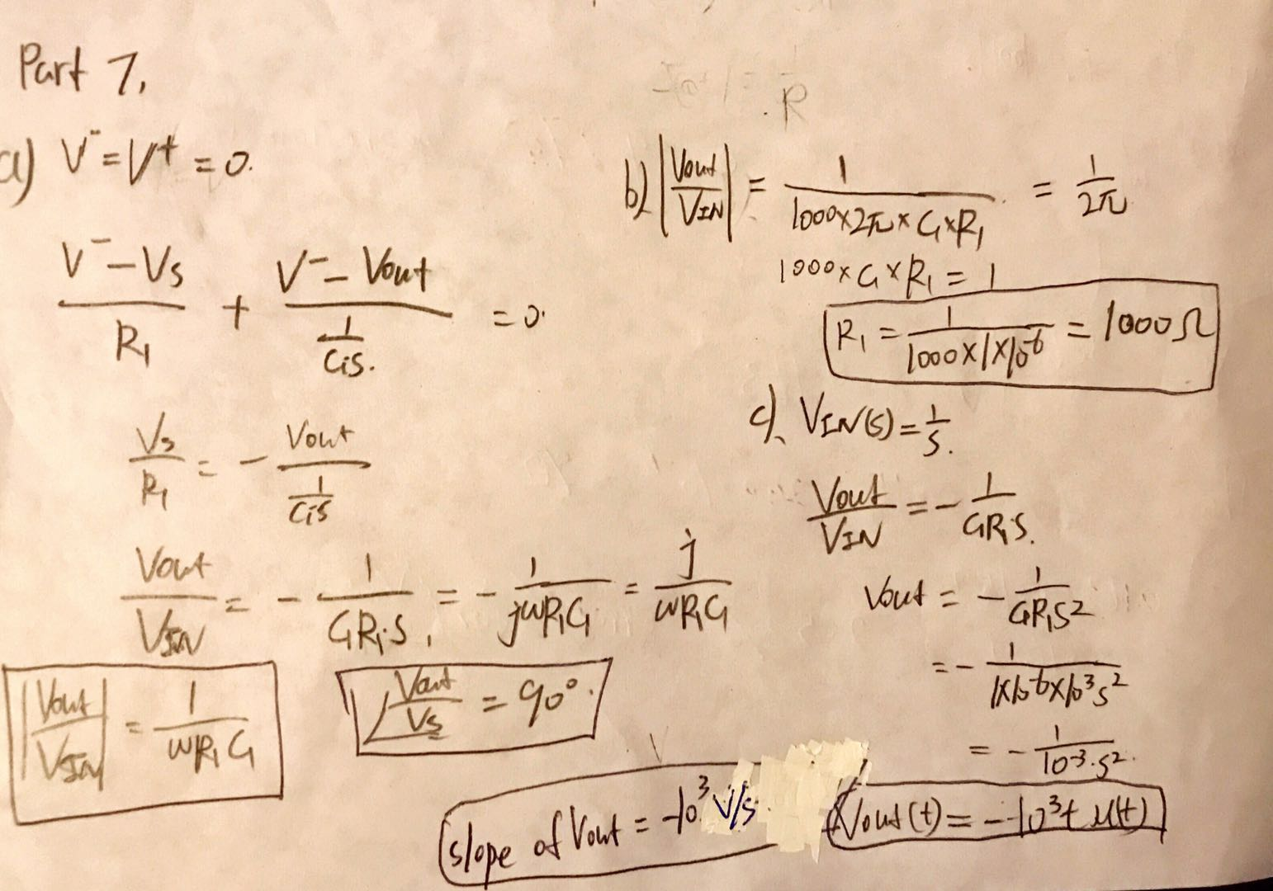

**Conclusion:**

Through all of the experiments, the operational amplifier plays an important rule. We can design an unity-gain buffer using Op-Amp. The unity-gain buffer can be able to provide a voltage is the same as input voltage, the it can prevent voltage divider. With the Op-Amp, we can design a second order low pass filter using two cascaded first order passive filter. In addition, the Op-Amp can invert or not invert the output voltage by setting the specification. The active LPF can prevent higher frequency voltage pass to the output. The Integrator can also increate a phase difference 90 degree in between the input and output voltage. Most of the experimental values match with the theoretical calculations excepted some high frequency measurement.